Docker DataBase Application

1. Create a sample springboot application and in the application.properties file add the configuration which connects to mysql database.

Eg:

|  |
| --- |
| # DataSource settings: set here your own configurations for the database  # connection. In this example we have "dojsb" as database name and  # "root" as username and password.  spring.datasource.url = jdbc:mysql://13.76.98.121:3306/dojdb  spring.datasource.username = root  spring.datasource.password = root  # Keep the connection alive if idle for a long time (needed in production)  spring.datasource.testWhileIdle = true  spring.datasource.validationQuery = SELECT 1  # Show or not log for each sql query  spring.jpa.show-sql = true  # Hibernate ddl auto (create, create-drop, update)  spring.jpa.hibernate.ddl-auto = create  # Naming strategy  spring.jpa.hibernate.naming-strategy = org.hibernate.cfg.ImprovedNamingStrategy  # Use spring.jpa.properties.* for Hibernate native properties (the prefix is  # stripped before adding them to the entity manager)  # The SQL dialect makes Hibernate generate better SQL for the chosen database  spring.jpa.properties.hibernate.dialect = org.hibernate.dialect.MySQL5Dialect  server.port = 8181 |

1. Also include hibernate.properties

Eg:

|  |
| --- |
| logging.level.org.hibernate.SQL=debug  # Hibernate  hibernate.dialect: org.hibernate.dialect.MySQL5Dialect  hibernate.show_sql: true  hibernate.hbm2ddl.auto: update |

1. Run the application as a maven project from pom.xml directory.

|  |
| --- |
| mvn clean install -DskipTests |

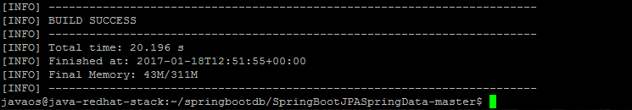

1. After build success, check for docker images

|  |
| --- |
| docker images |

1. Run the docker-compose file for starting the application and mysql database.

Docker-compose.yml

|  |
| --- |
| web:  image: springdb  command: docker run --detach -volumes-from --name=test-mysql --env="MYSQL_ROOT_PASSWORD=root" mysql  links:  - db  ports:  - "8181:8181"  db:  image: mysql  ports:  - "3306:3306"  environment:  MYSQL_ROOT_PASSWORD: root  MYSQL_PASSWORD: root  MYSQL_DATABASE: dojdb |

1. When the application starts successfully, access the application through browser.

|  |
| --- |
| <http://13.76.98.121:8181/booking/create> |

You will get an output status.

1. Check the mysql db using MySqlYog client/others .

